How to set up a Sprint Map
https://www.britishorienteering.org.uk/mapping_resources
How to make a sprint map:
This does not include how to generate contours

- Download Open Orienteering Mapper
The latest release of the open-source Open Orienteering Mapper is available from the Open Orienteering Website. This software runs on Android, Linux, macOS and Windows.

- Download British orienteering symbol sets for Open Orienteering Mapper: https://bof2.sharepoint.com/:u:/g/Competitions/EXMVvONcIElInXO-wg6ZpuMB_3m8g0Rs5UXEIsOpf8KzTA?e=glc1Vu
Export the symbol folder set to somewhere handy.

- OS Mastermap Data download on digimap www.digimap.edina.ac.uk

Follow the sign in instructions and then go to OS Data Download.

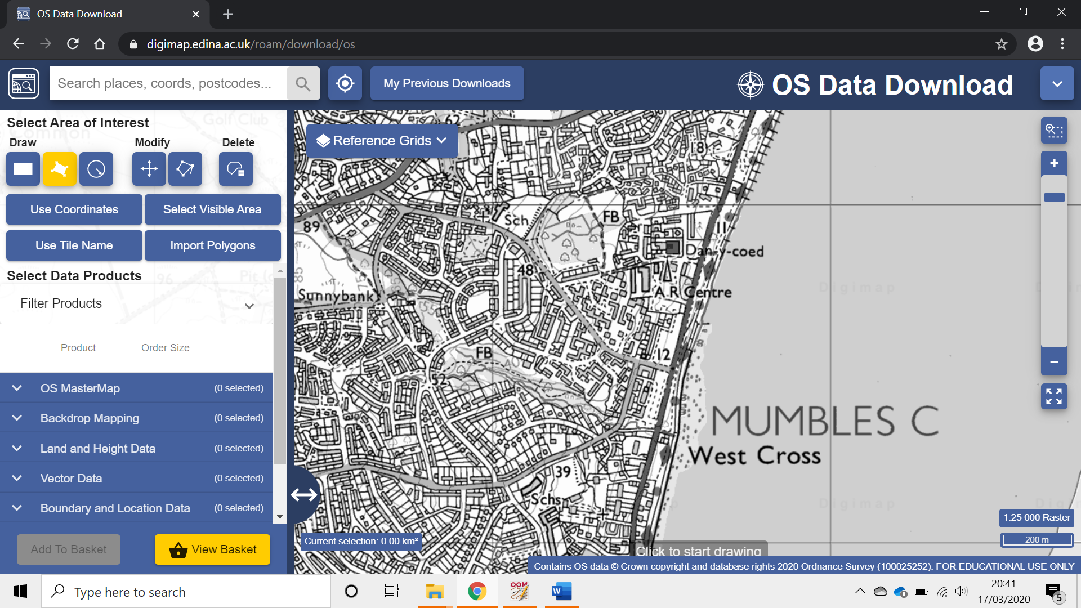

Zoom into the area you want to map and draw a box over the area.
Then under “Background Mapping” select Mastermap 1:1000 Raster, add to basket and follow the steps to order the data.
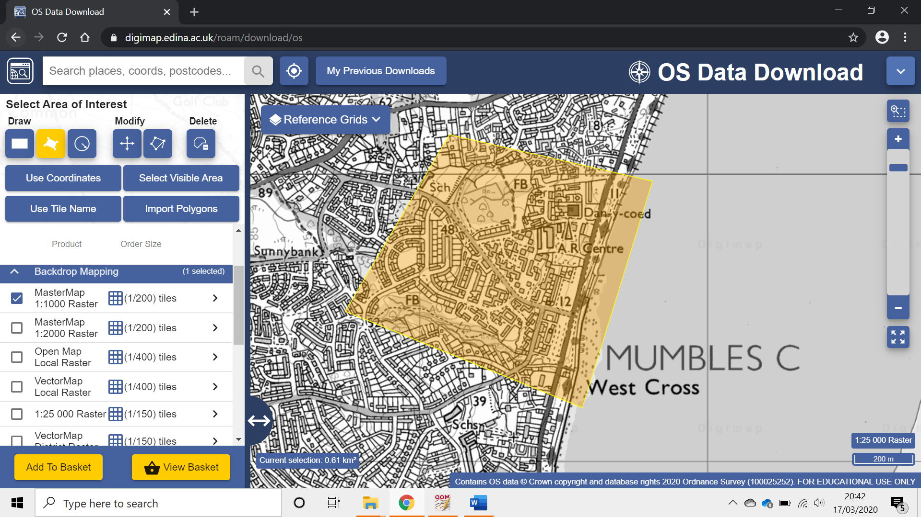

Once you have ordered the data you will be sent a download link.
The download comes in the form of a compressed zip folder so you will need to extract that folder too and save it somewhere – best to keep all the files for a particular map in one folder.
Aerial data can also be downloaded through digimap if required. Follow the same steps to load as a background map as with the OS Mastermap files.

Setting up a sprint map file
- Open up Open orienteering Mapper
- Select Create a new map…
- Change the scale to 1:4000
- Load symbol set from a file…
- Load in the symbol set “ BOF O_Map 4000 OOM v1.1_ISSprOM2019.ocd.omap”
- Save the map as “yourarea”.omap in the same folder as the rest of the files.
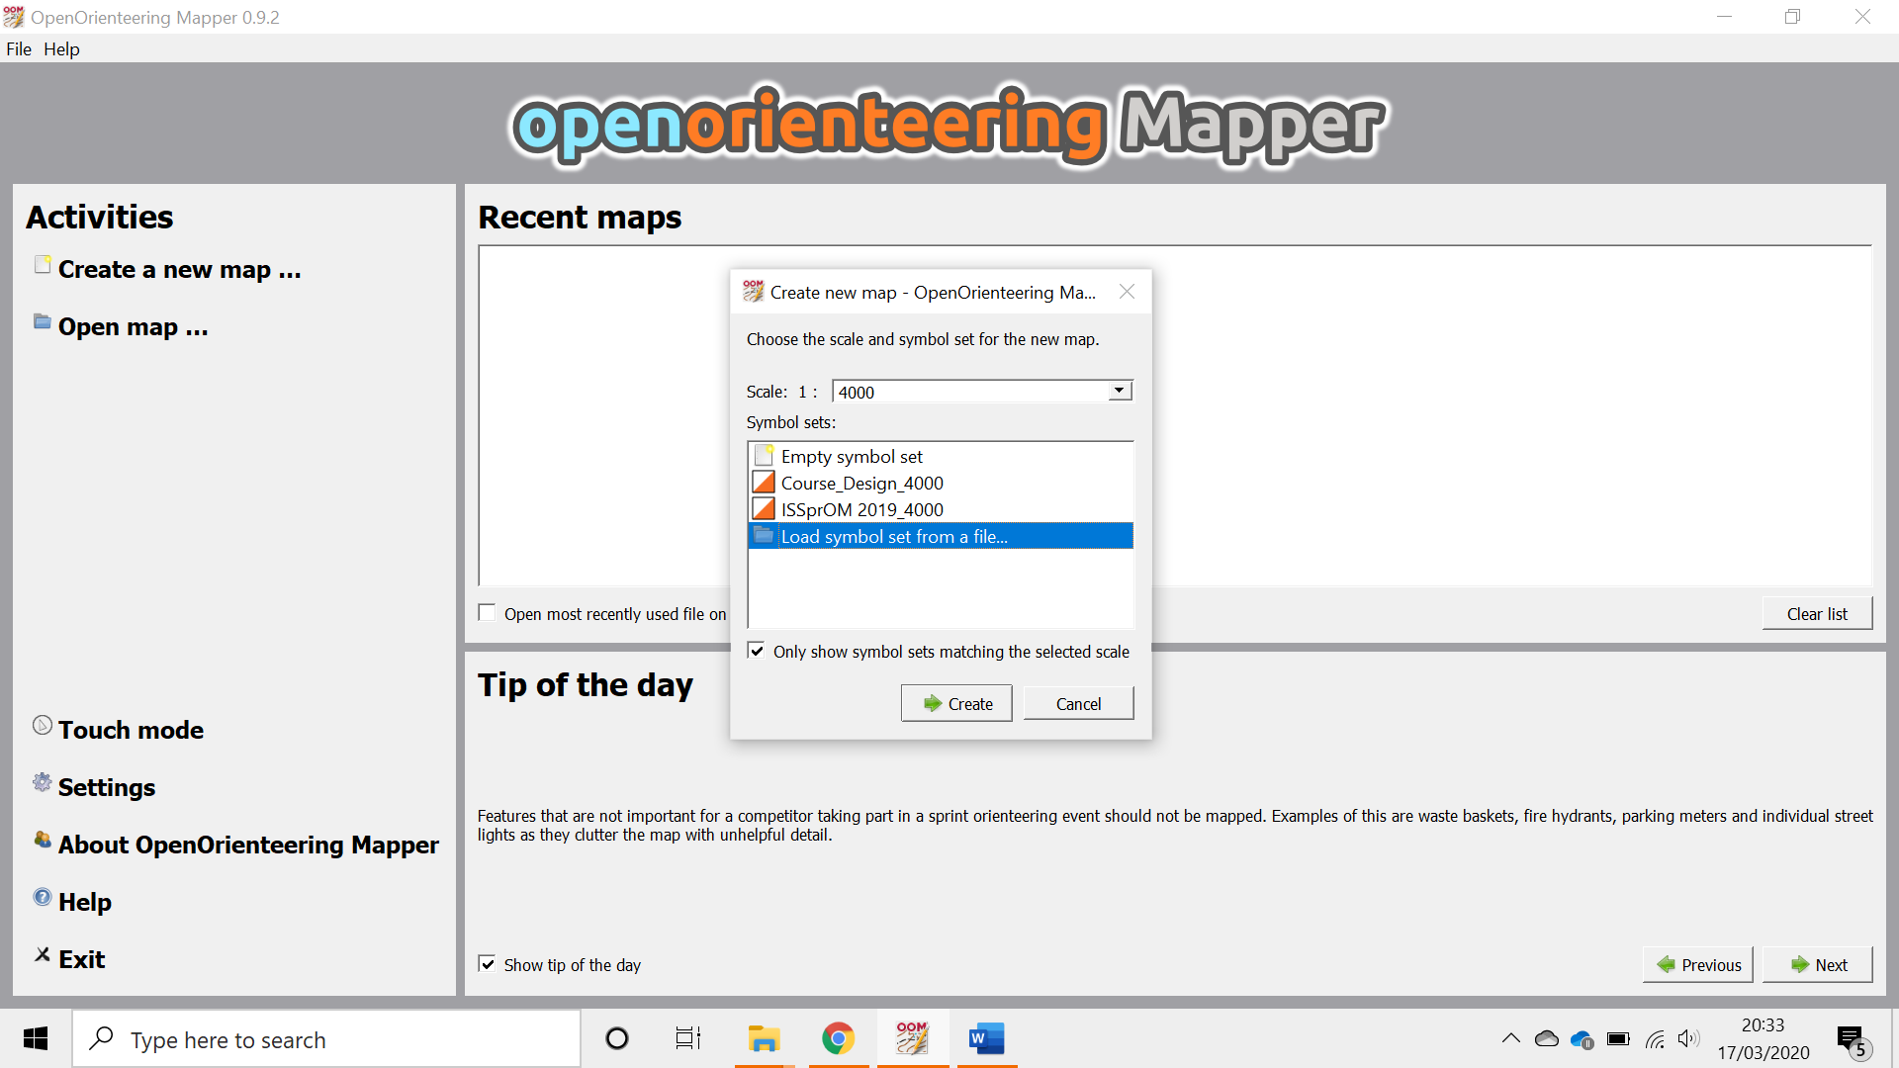

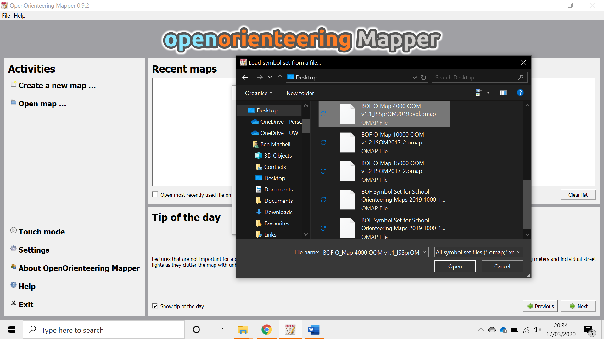

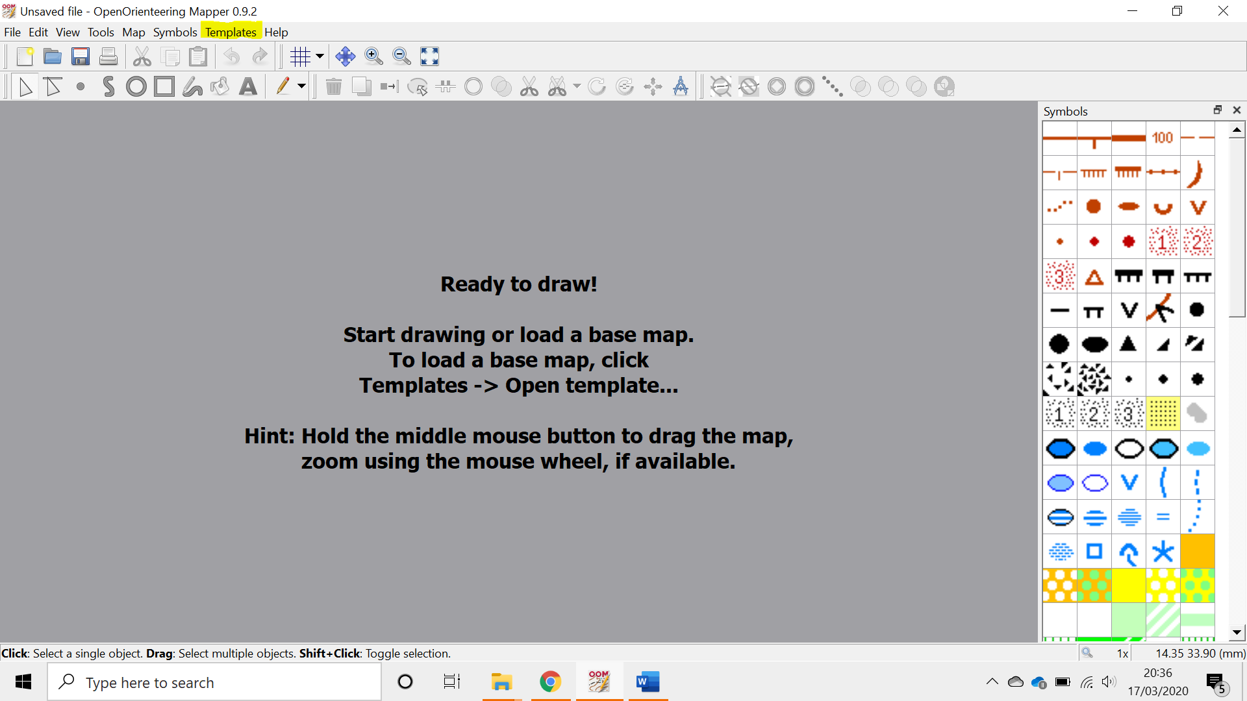

You now have a map set up ready to be drawn!

Loading in the background maps
- Go to templates > template setup window. (This will appear below the symbols in the right sidebar.)
Using this you can switch on and off different templates as well as changing the transparency of the images which can help when tracing etc.

- Go to templates > Open template or you can use the green cross in the bottom right of the template setup window.
- Open the mastermap files ‘.tif’which you downloaded from Digimap.
- A pop up will ask you to specify how to position or scale the image – select ‘geofreferenced’ and on the next window accept the default ‘local’ referencing system.

That’s it!

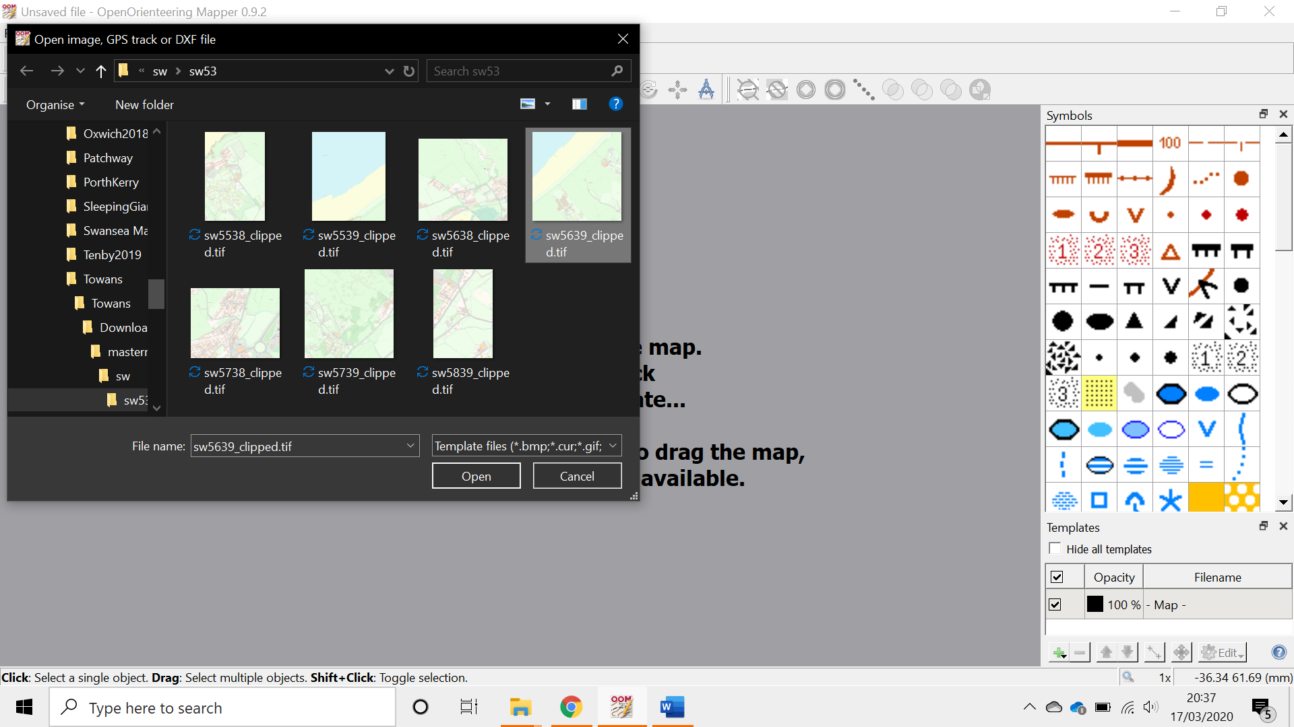
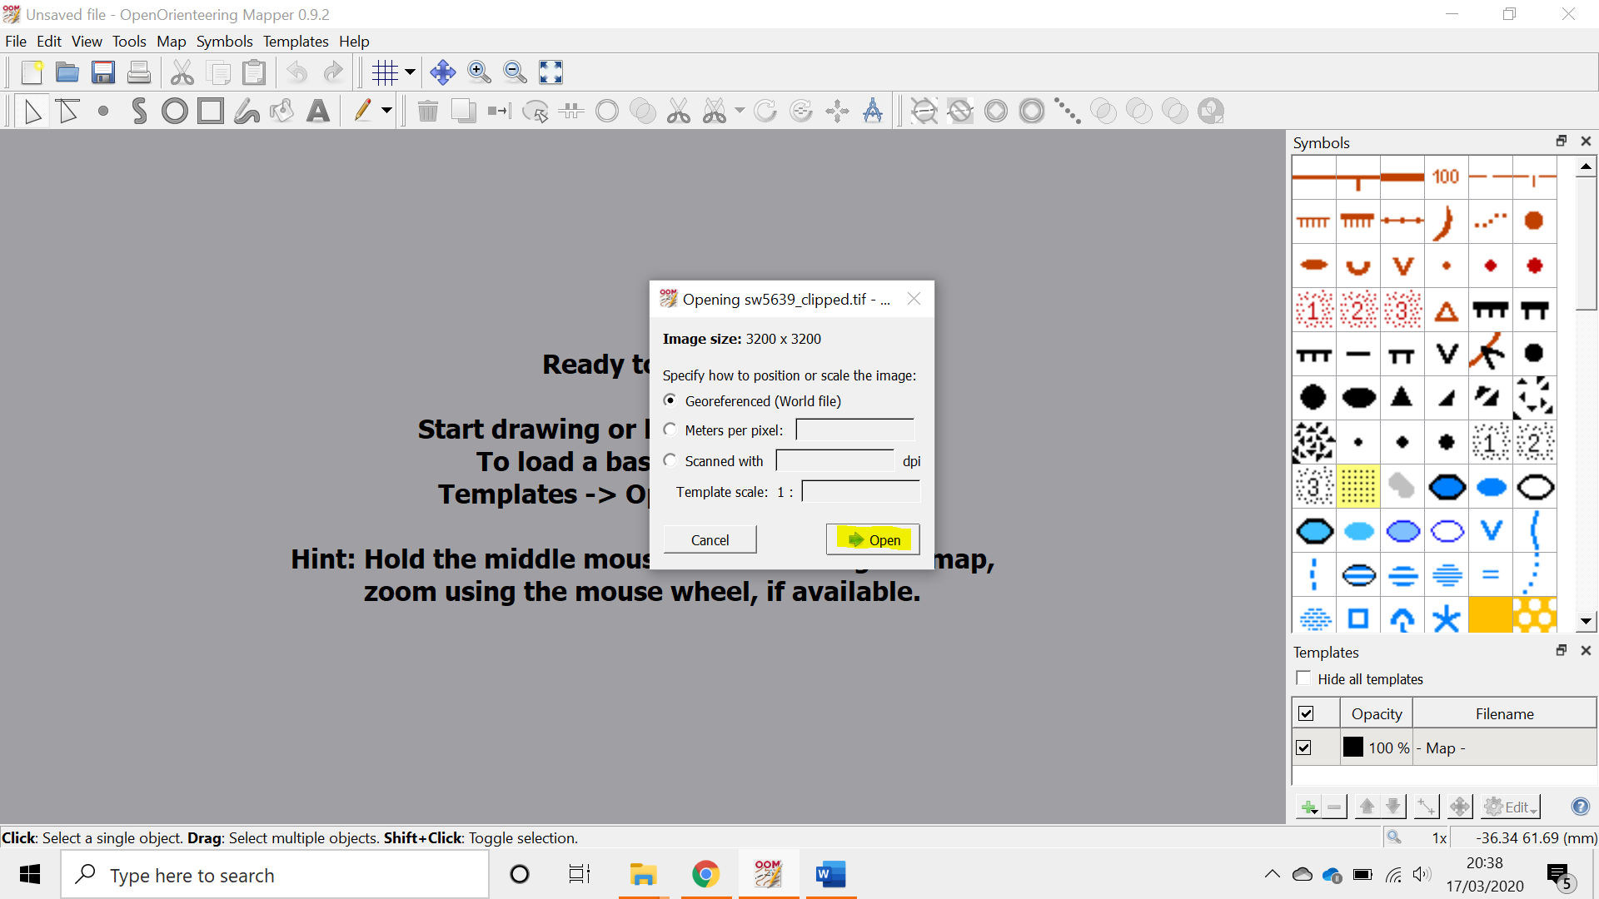

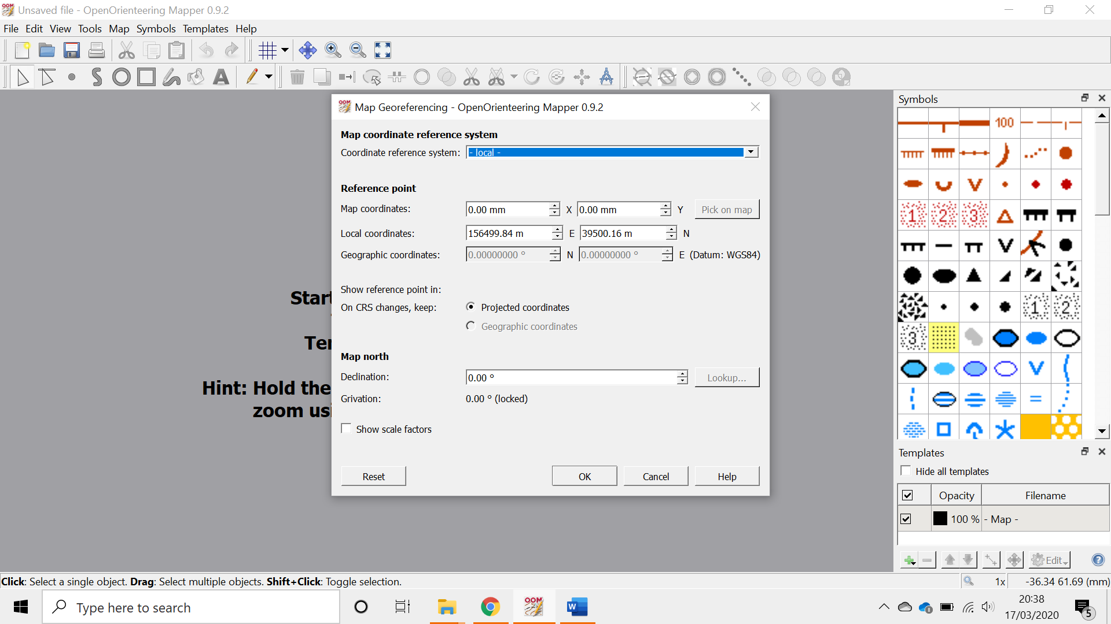

Don’t forget to follow the specification and particularly make sure gaps between uncrossable symbols are 0.40mm or the same width as an uncrossable wall!

Open orienteering mapper has lots of shortcuts which can speed up drawing. The bottom bar of the window gives some help.

Any questions feel free to ask.

